CSIT314 Software Development Methodologies - Group Project

Sprint 2 - US19: Interior designer log out
Interior Design Platform - Interior Designer
All diagrams were drawn in draw.io. Open "US19 Interior designer log out.drawio" in this folder to edit them - each diagram is its own page in that file. The exported images are in the "diagrams" folder.

Assumptions
- The system is the Interior Design Platform from the project specification. Sprint 2 covers the Interior Designer's stories (log in, company profile and log out, US13 - US19) and the Platform Manager's log in (US39).
- We follow B-C-E: the actor only talks to the boundary (page), the boundary only talks to the controller, and the controller works with the entity classes. There is one controller per use case.
- Every designer page has a "Log out" button in the header. It sends a POST to /designer/logout. Opening /designer/logout with GET is not allowed and doesn't log anyone out.
- InteriorDesignerLogoutController reuses the US2 LogoutController.logout(), then clears anything left in the session (for example a delete confirmation from US17).
- No entity class is needed. Logging out only ends the browser session - it doesn't change the user account or the company profile.
- After logging out the designer goes to the designer login page with "You have logged out successfully". If the session had already ended, the message is "Your session has already ended". The message is only shown once.
- A designer can always log out, even if their account or profile was suspended after they logged in.
- Logging out only ends the session in this browser, not on other devices.
- The User Admin's log out (US2, /logout) is not changed.

1. User story
Story ID | US19
User story | As an interior designer, I want to log out so that other people cannot use my account.
Actor | Interior Designer
Priority | High
Story points (estimate) | 1
Acceptance criteria | 1. Every designer page has a "Log out" button in the header.  2. Given I am logged in and click "Log out", then my session ends, I go to the designer login page and see "You have logged out successfully".  3. Given my session has already ended, when I log out, then I see "Your session has already ended".  4. After logging out, opening any designer page sends me to the designer login page, and I can't create, update or delete a company profile.  5. Logging out doesn't change my account or company profile, and I can log in again.
Tasks | T19.1 Write the use case description and draw the use case diagram  T19.2 Draw the B-C-E class diagram and the sequence diagram  T19.3 Draw the wireframes for the log out button, logged out, session already ended and a blocked page  T19.4 Write the unit tests first (TDD) for InteriorDesignerLogoutController and the log out page  T19.5 Code InteriorDesignerLogoutController, reusing the US2 LogoutController  T19.6 Code InteriorDesignerLogoutPage and add the "Log out" button to the designer header  T19.7 Show the one-time message on the designer login page  T19.8 Run the test cases, fix bugs and push to the repo so the CI pipeline runs the unit tests

2. Use case diagram
The user story becomes one use case, UC19 Interior designer log out. The Interior Designer is the only actor.
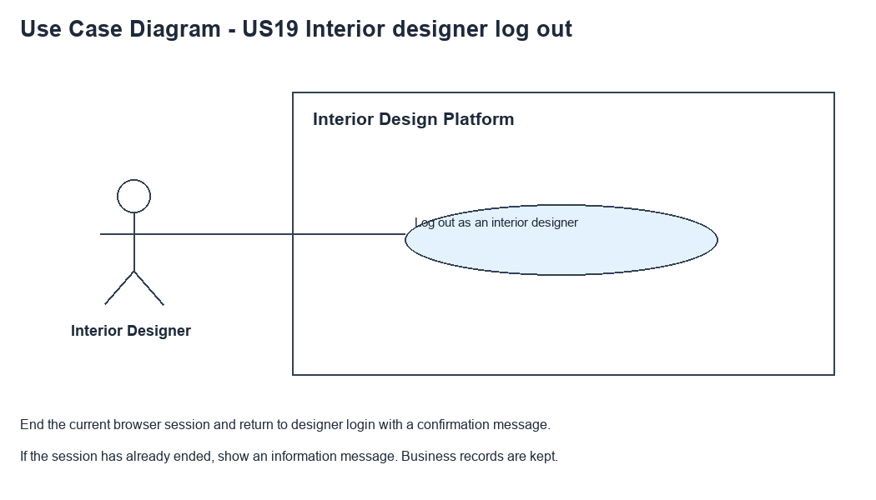
Figure 1: Use case diagram for US19 Interior designer log out

3. Use case description
Use case | UC19 Interior designer log out
Actor | Interior Designer
Brief description | The Interior Designer logs out so other people can't use their account on this browser.
User story | US19: As an interior designer, I want to log out so that other people cannot use my account.
Preconditions | The Interior Designer is logged in (UC13).
Trigger | The Interior Designer clicks "Log out" in the header of any designer page.
Basic flow | 1. The Interior Designer clicks "Log out".  2. The system checks that there is a logged-in session.  3. The system ends the session and clears all session data.  4. The system shows the designer login page with "You have logged out successfully".
Alternative flows | 2a. There is no logged-in session (it already ended): the system clears anything left in the session and shows the designer login page with "Your session has already ended".
Postconditions | The session is cleared. Designer pages need a new login.  The user account and company profile are not changed.

4. Wireframes
The wireframes were drawn in draw.io. They are low-fidelity: they show the layout and the flow, not the final colours. The orange numbers match the notes under each screen.

4a - Logout button
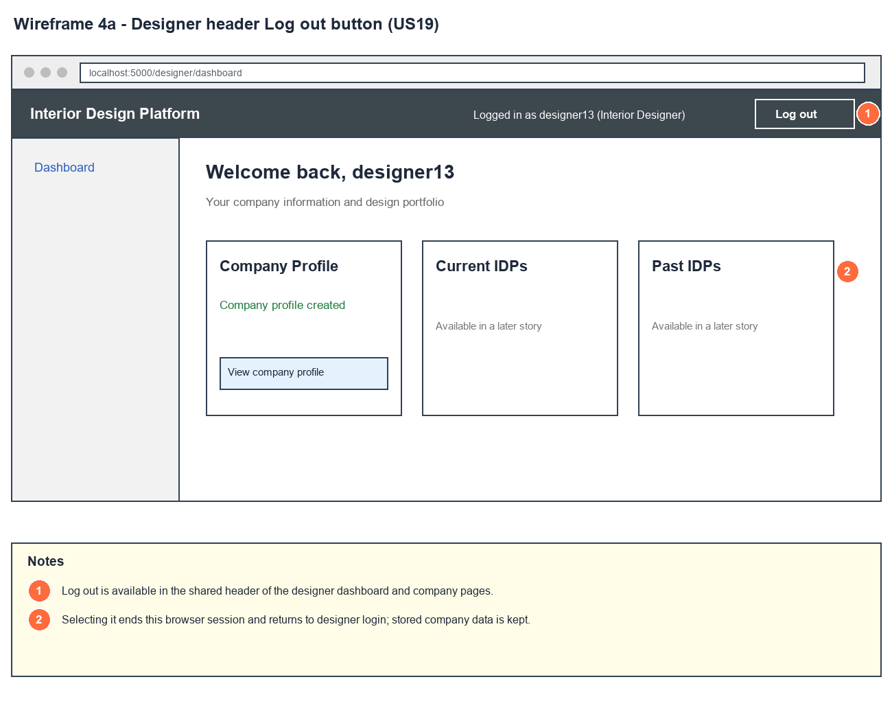
Figure 2: Wireframe 4a - Logout button (US19)

4b - Logged out
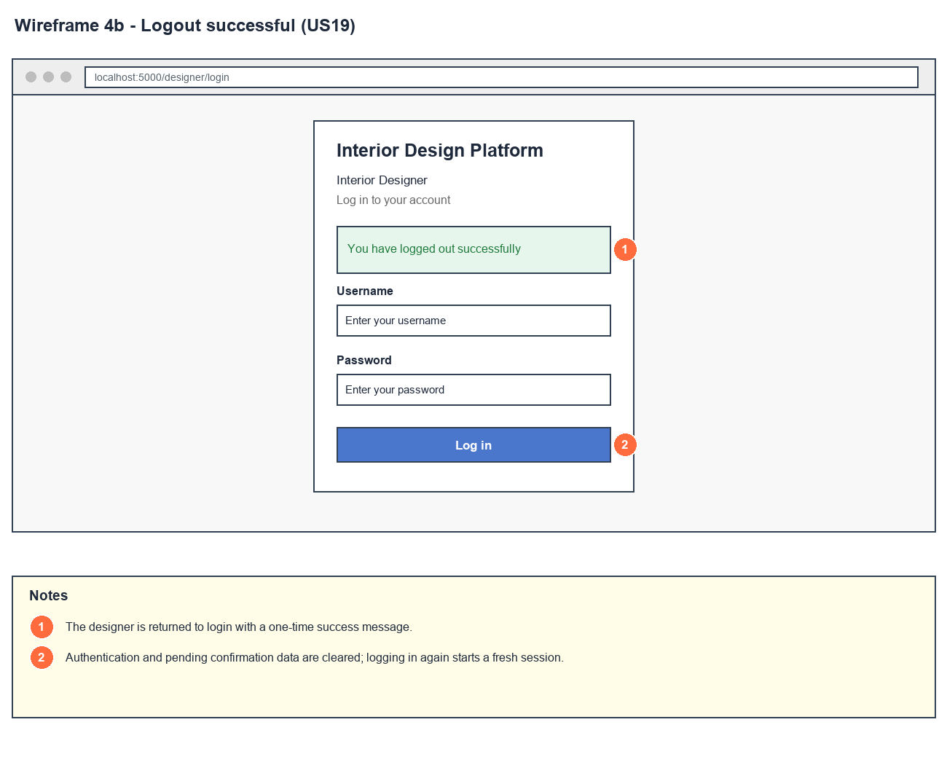
Figure 3: Wireframe 4b - Logged out (US19)

4c - Session already ended
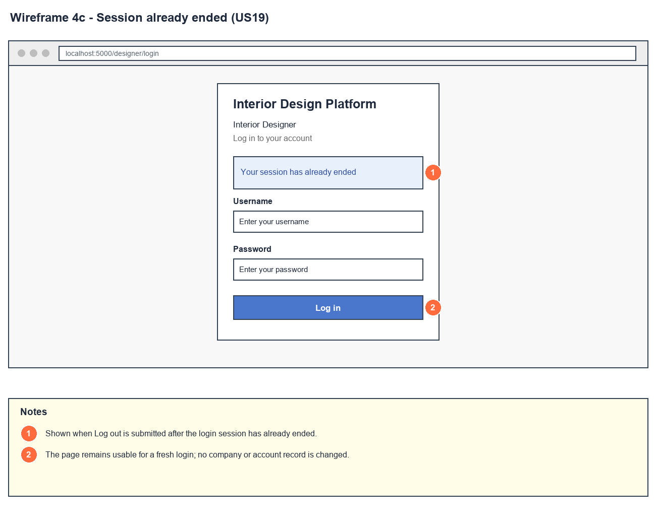
Figure 4: Wireframe 4c - Session already ended (US19)

4d - Protected page blocked
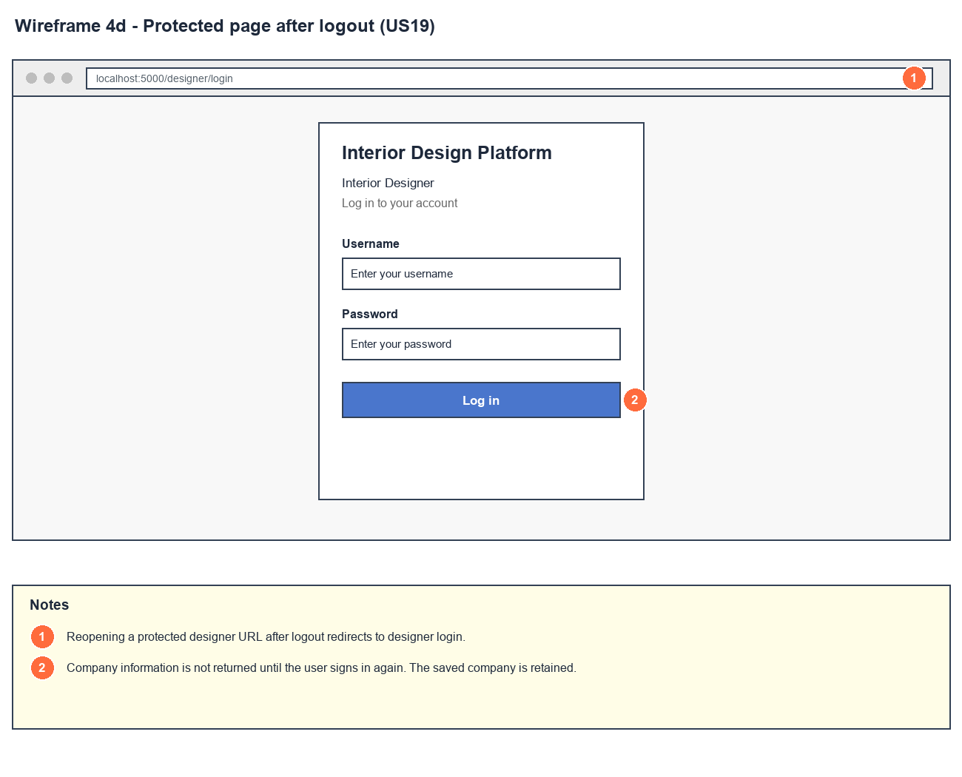
Figure 5: Wireframe 4d - Protected page blocked (US19)

5. B-C-E class diagram
The solid line means the boundary calls the controller. The dashed lines mean the controller uses the other classes. Only the operations needed for this use case are shown.
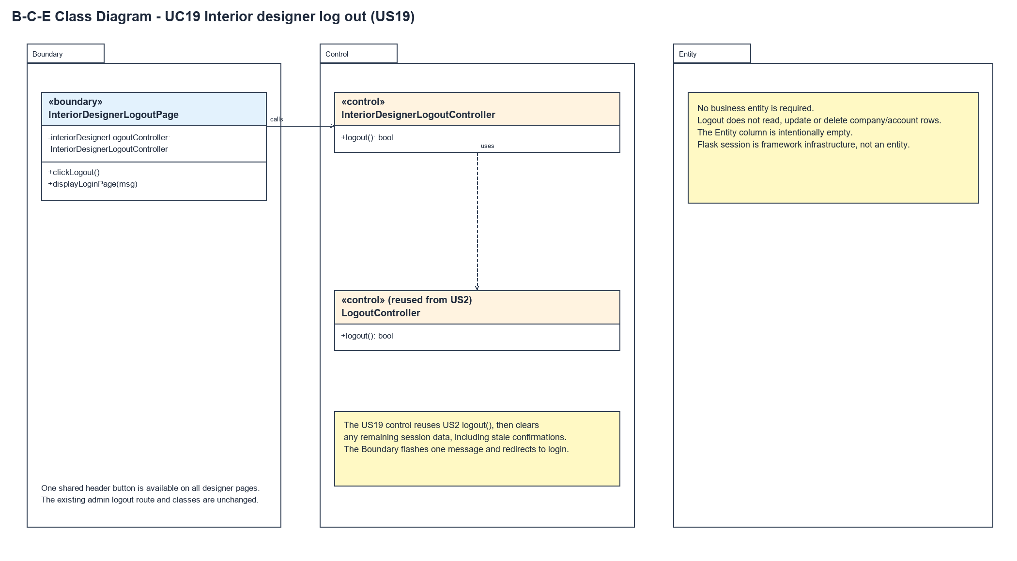
Figure 6: B-C-E class diagram for US19 Interior designer log out
Layer | Class | What it does
Boundary | InteriorDesignerLogoutPage | The "Log out" button in the designer header. clickLogout() asks the controller to log out, then displayLoginPage(msg) shows the right message once and goes to the designer login page.
Control | InteriorDesignerLogoutController | Controller for UC19. logout() calls the US2 LogoutController, then clears the whole session. Returns true if a logged-in session was ended.
Control | LogoutController (from US2) | logout() ends the session if a userId is in it, and returns true or false.
Entity | (none) | No entity is needed - logging out doesn't read or change any account or company data. The Flask session is part of the framework, not an entity.

6. Sequence diagram
The sequence diagram follows UC19. The page asks InteriorDesignerLogoutController to log out, and it calls the US2 LogoutController. The first alt checks if a userId is in the session: if so the session is cleared and true is returned (steps 2 - 3), otherwise false is returned (alternative flow 2a). The designer controller then clears the session again to remove anything left over. The second alt shows "You have logged out successfully" (step 4) or "Your session has already ended" (alternative flow 2a).
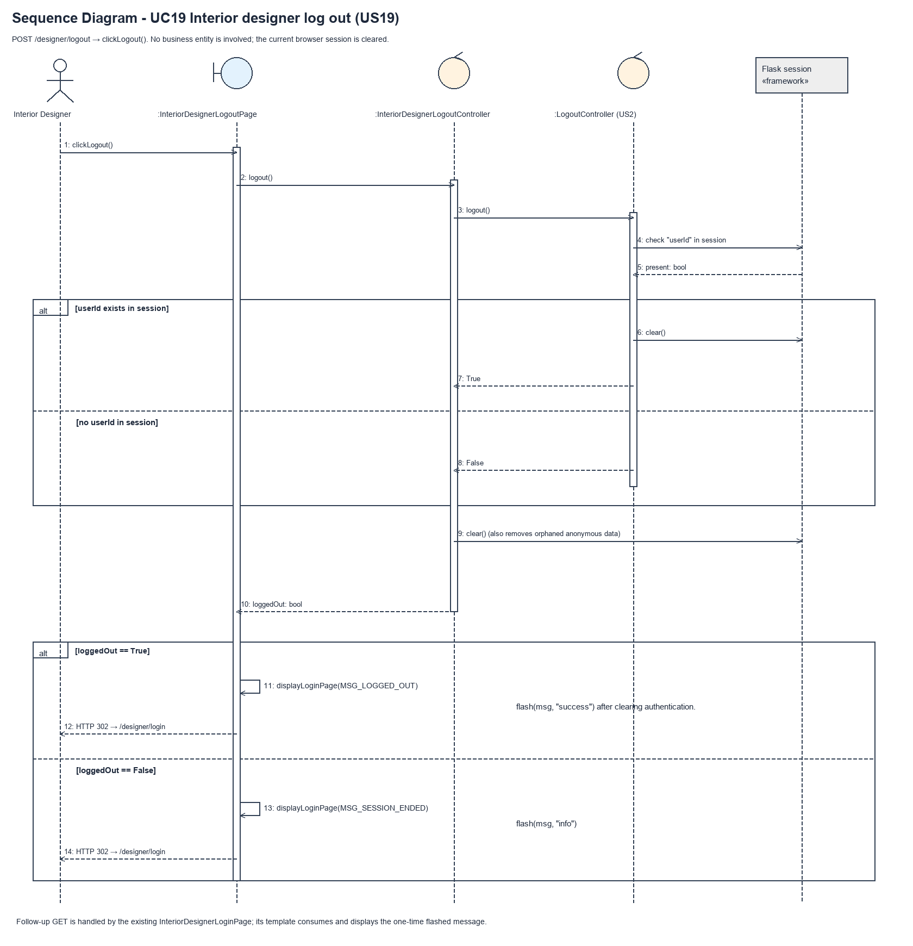
Figure 7: Sequence diagram for UC19 Interior designer log out

7. Test cases
Test data used below (same as database/seedData.py and the test files): user profiles User Admin (id 1), Interior Designer (id 2), Customer (id 3) and Platform Manager (id 4), all Active. User accounts admin01 / Admin@123 (User Admin) and cust001 / Cust@123 (Customer). The designer account designer13 / Design@123 (Tengku Uda Designer, Interior Designer profile) is made first with UC8. Company data: Uda Interiors, "Interior design for homes.", "Space planning, renovation", hello@udainteriors.com, +65 6123 4567, 10 Design Street.

7a. System test cases (black box)
Equivalence partitioning and boundary value analysis were used to pick the test data. Fill in "Actual result" and "Pass/Fail" after running each test.
Test ID | Scenario | Prerequisites | Test steps | Test data | Expected result | Actual result | Pass / Fail
TC19.1 | Log out | Logged in as designer13. | 1. Click "Log out" in the header | - | Designer login page with "You have logged out successfully". The username box is empty.
TC19.2 | Log out button on every designer page | Logged in as designer13. Has a company profile. | 1. Open the dashboard, view, create, update, delete and search pages | - | Every page has a "Log out" button.
TC19.3 | Pages are blocked after logging out | TC19.1 done. | 1. Open /designer/dashboard  2. Open /designer/company | - | Both send me to the designer login page.
TC19.4 | Session already ended | Not logged in. | 1. Send a log out request (e.g. click "Log out" in an old tab) | - | Designer login page with "Your session has already ended".
TC19.5 | Message is only shown once | TC19.1 done. | 1. Refresh the login page | - | The "logged out" message is gone.
TC19.6 | Log in again | TC19.1 done. | 1. Log in as designer13 | designer13 / Design@123 | Designer dashboard. The company profile is unchanged.
TC19.7 | Can't change the company after logging out | TC19.1 done in a browser that had the update form open. | 1. Click "Save changes" on the old update form | Unauthorised change | Sent to the designer login page. The company profile is unchanged.
TC19.8 | Other browser stays logged in | designer13 logged in on two browsers. | 1. Log out on the first browser  2. Open the dashboard on the second browser | - | The second browser is still logged in.

7b. Unit test cases (for TDD)
These are written before the code (test-driven development) and run automatically in the CI pipeline. They cover normal inputs, abnormal inputs and boundary values. Each one matches a test function in tests/test_us19_interiorDesignerLogout.py (e.g. UT19.1 is test_ut19_1_...). Pass / Fail is from the pytest run on 23 October 2026.
Test ID | Class and method | Input / setup | Expected output | Type | Pass / Fail
UT19.1 | InteriorDesignerLogoutController.logout() | Session has userId, profileId and username | Returns true. Session is empty | Normal | Pass
UT19.2 | InteriorDesignerLogoutController.logout() | Empty session | Returns false. Session is empty | Abnormal | Pass
UT19.3 | InteriorDesignerLogoutController.logout() | Called twice | True, then false | Boundary | Pass
UT19.4 | InteriorDesignerLogoutController.logout() | Session has a delete confirmation | Returns true. Confirmation removed | Normal | Pass
UT19.5 | InteriorDesignerLogoutController.logout() | No userId but old username and confirmation left | Returns false. Session is empty | Abnormal | Pass
UT19.6 | Designer dashboard header | Logged in as designer13 | Has the "Log out" button posting to /designer/logout | Normal | Pass
UT19.7 | Designer page header | Open view, create, update, delete and search pages | Every page has the "Log out" button | Normal | Pass
UT19.8 | InteriorDesignerLogoutPage.clickLogout() | POST /designer/logout | Redirects to /designer/login | Normal | Pass
UT19.9 | InteriorDesignerLogoutPage.displayLoginPage() | POST and follow the redirect | "You have logged out successfully", login form shown, no "Logged in as" | Normal | Pass
UT19.10 | InteriorDesignerLogoutPage.clickLogout() | POST /designer/logout | No userId, profileId or username in the session | Normal | Pass
UT19.11 | InteriorDesignerLogoutPage.displayLoginPage() | POST with no session | "Your session has already ended" | Abnormal | Pass
UT19.12 | InteriorDesignerLogoutPage.clickLogout() | Log out twice | Second time shows "Your session has already ended" | Boundary | Pass
UT19.13 | /designer/logout route | GET /designer/logout | HTTP 405. Still logged in | Abnormal | Pass
UT19.14 | Designer pages after logging out | GET dashboard, view, create, update, delete and search | All redirect to /designer/login | Normal | Pass
UT19.15 | Create after logging out | POST /designer/company/create | Redirects to login. No profile saved | Abnormal | Pass
UT19.16 | Update after logging out | POST /designer/company/update | Redirects to login. Data unchanged | Abnormal | Pass
UT19.17 | Delete after logging out | POST the old delete confirmation | Redirects to login. Data unchanged | Abnormal | Pass
UT19.18 | InteriorDesignerLogoutPage.clickLogout() | Logged in, with a profile | Company profile unchanged, account still Active | Normal | Pass
UT19.19 | Log in again | Log out, then log in as designer13 | Dashboard opens and the company profile is still there | Normal | Pass
UT19.20 | Delete after logging in again | Old confirmation from before logging out | HTTP 400. Profile kept | Abnormal | Pass
UT19.21 | InteriorDesignerLogoutPage.clickLogout() | Account suspended after logging in | "You have logged out successfully". Session cleared | Boundary | Pass
UT19.22 | InteriorDesignerLogoutPage.clickLogout() | designer13 logged in on two browsers, logs out on one | First browser redirects to login, second still opens the dashboard | Normal | Pass
UT19.23 | Response headers | Dashboard and the page after logging out | Cache-Control is "no-store" | Normal | Pass
UT19.24 | LogoutPage (US2, /logout) | admin01 logs out | "You have logged out successfully" and /dashboard redirects to login | Normal | Pass
UT19.25 | InteriorDesignerLogoutPage.displayLoginPage() | Log out, then open the login page again | Message shown once only | Boundary | Pass
UT19.26 | View company profile page | Logged in as designer13 | Has the log out form, but the company content has no form fields | Normal | Pass

